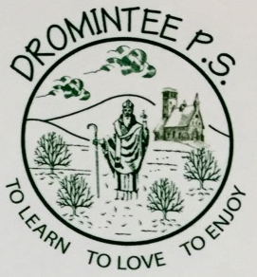 | Dromintee Primary School
 | 8 Ballynamadda Road,  Killeavy,  Newry, Co Down,  BT35 8TD | Telephone: (028) 3088 8383  Fax: (028) 3088 8470  www.drominteeps.com  Email: info@dromintee.killeavy.ni.sch.uk

Notice for academic year 2020 2021
Due to the Covid-19 pandemic and the restrictions on numbers attending church and the need to social distance, there will be no altar servers used in our parish for the foreseeable future. We thank all our families for their support in the past and we look forward to re-establishing the rota at some point in the future.
Mrs McKeown

