Religious Education Policy

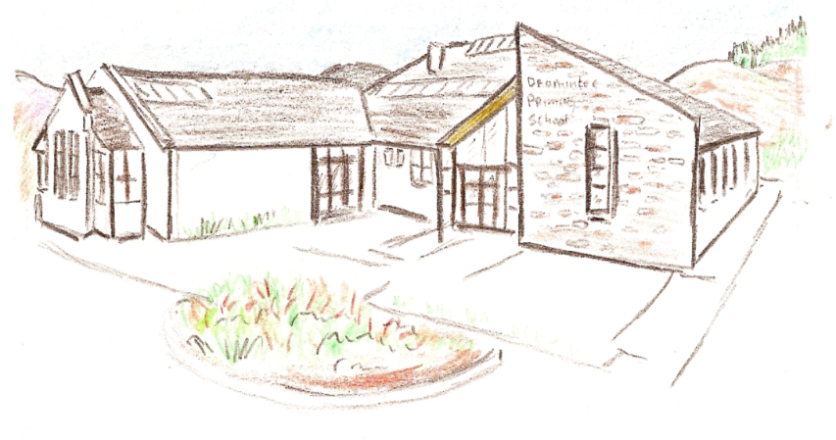

An Léann An Grá An Sult

Approved by Governors 14th October 2019

Dromintee Primary School Policy Document for Primary Religious Education in the Archdiocese of Armagh

“Let the little children come to me, and do not hinder them, for the kingdom of heaven belongs to such as these.” Matthew 19:14

Catholic schools are inclusive schools which are founded on the principles of equality, respect and love. The Catholic school has an integral part to play in helping children to experience God’s love, understand the teachings of Jesus and to embrace a way of life rooted in a friendship
with Him.
Pope Francis reminds us that the first proclamation that must ring out over and over in our Religious Education is that “Jesus Christ loves you; He gave His life to save you; and now He is living at your side every day to enlighten, strengthen and free you”.
In the Catholic school the educational mission of the Church finds a particular important expression. As with all schools, the Catholic school is concerned with the ongoing
development of the potential of every individual. What is distinctive, however, in the Catholic school is that it is centred on the person of Jesus Christ, His teaching, and living a life that emulates these Christian values.

INTRODUCTORY STATEMENT
The Board of Governors in Dromintee Primary School together with the Principal and staff, wish to promote a highly visible Catholic ethos in the school where every child is valued. We are a rural parish and we enjoy strong links with the Church, families and the wider community. In line with the Northern Ireland Curriculum aim we wish every pupil to achieve their full potential. Our school motto – An Léann, An Grá, An Sult (Learn, Love, Enjoy) is at the core of what we do.

GENERAL INFORMATION
Diocesan Information
Diocese: Archdiocese of Armagh
Senior Trustee: Archbishop Eamon Martin
Parish Information
• Dromintee/Jonesborough Parish
• Name of Parish Priest: Fr Seamus White
• Name of Deacon: The Rev Mr Martin Brennan
School Information
• Dromintee Primary School
• Name of Chaplain: Fr Seamus White
- Names of Board of Management/Governors members: Mr Adrian Gray, Mrs Roisin Martin, Fr Seamus White, Mr Stephen Begley, Ms Lisa Mulkerns-McCrink, Mr Anthony Flynn, Mr Damian McGenity, Mrs Emma McCourt and Briege Boyle
- Name of Designated Member of Board with specific responsibility for ethos: Mrs Roisin Martin
• Name of Religious Education Co-ordinator: Mrs Michelle Kelly

AIM OF RELIGIOUS EDUCATION
The aim of Religious Education in the school is principally to help children mature in relation to their spiritual, moral and religious lives, through their encounter with, exploration and celebration of the Catholic faith. Its main function is to explore step by step the mystery of Christ, the teaching of the Church and its application to daily life. It needs to be clearly focused and should encourage young people to be critical, analytical and reflective.
In a Catholic school, therefore, the Religious Education of pupils is accomplished in two equal and complementary ways:
(i) through the totality of the experiences in the school and;
(ii) through the Religious Education programme, Grow in Love.
A community hands on its faith and values most effectively by living them. Faith development should be promoted through the entirety of the school experience - including regular contact with the wider parish community, celebration of the sacraments, and assemblies centred on
prayer - as much as by the learning which takes place in the formal Religious Education class.
Children will learn how to participate in prayer, they will know the traditional prayers by the year they receive Holy Communion for the first time and be competent in saying them.
Children will develop virtue, personal and social responsibility, ecological consciousness and the ability to act in accordance with an informed conscience when making moral decisions.
Children will develop Christian attitudes and values: for example, love, justice, compassion, truthfulness and respect and they will develop an understanding of what membership of the Church means.

RELIGIOUS EDUCATION POLICY STATEMENT
At Dromintee Primary School our mission is to develop as a community of faith and learning, providing the highest quality of education and offering formation through the promotion of the Gospel values, through celebration and worship, and through service to the common good. We
believe that faith in Jesus Christ is central to the full and harmonious development of the person: intellectual, physical, emotional, moral and spiritual. Our school provides Religious Education as a core subject in the curriculum. At Dromintee PS we value and promote the distinctive but complementary roles of home, school and parish as together we work to promote the well-being and freedom of every person, made in the image and likeness of God.

RELIGIOUS EDUCATION CURRICULUM AND PROGRAMME
The Catholic Preschool and Primary Religious Education Curriculum for Ireland, published by the Irish Episcopal Conference in 2015, is the formal Religious Education curriculum for primary schools in the whole island of Ireland. It provides a structured outline of what Religious Education, as an academic discipline in Catholic schools, contributes to the Catholic education and formation of young people. This curriculum provides a solid foundation for Grow in Love, the
Religious Education programme, used in Dromintee PS and all other resource material used to enhance Religious Education lessons. This curriculum also emphasises the cross-curricular nature of Religious Education, which pervades all academic subjects and aspects of life and
education in Catholic schools, for instance, policies concerned with Anti-Bullying, RSE, PDMU. For more than a decade the pupils of Dromintee Primary school walk to Friday morning mass in St Patrick’s Church. Each year group P3 – P7 takes turns at leading the Mass, with every child taking on a role. Every child in P1 and P2 has an opportunity, on a rota basis, to carry up the offertory gifts.

PARENTS AND GUARDIANS
Dromintee PS appreciates that parents and guardians are the primary educators of their children and therefore partnership between school and parents / guardians needs to be sustained and strengthened. This is achieved in Dromintee PS through information evenings for
parents and guardians. For children receiving the sacraments, this is complemented by participation in programmes such as Do This In Memory Of Me in preparation for Holy Communion for the First Time.
There is ongoing communication with parents and guardians regarding the Religious Education programme Grow in Love through the home activity, which they are encouraged to complete together with their children on a weekly basis. Parents and guardians are asked to support teachers in school by reinforcing Gospel values at home. Parents are encouraged to attend Mass each Friday, a monthly assembly (led by individual year groups) and events during Catholic School’s Week. We welcome the grandparents to our school each year to make St Brigid’s crosses with the children.

GOVERNORS
The Board of Management / Governors has overall responsibility for the curriculum in a Catholic school. It is guided in its management of Religious Education by the principal, teachers and RE Co-ordinator. It has a particular responsibility for the appointment of teachers who are suitably qualified and who will support and promote the aims and objectives of the Religious Education policy and ethos of the Catholic school. The Board of Management / Governors should also encourage and support the principal and teachers in their personal and professional faith
development. They need to ensure that Religious Education is well resourced with suitable catechetical materials and that the correct time is allocated for its delivery in the classroom.

PRINCIPAL
It is essential that the Catholic ethos of the school is promoted by the principal. This is evident by her words and actions. The principal endeavours to make possible a coherent and co-ordinated approach to Religious Education, by working closely with the local parish to ensure a holistic contribution to the pupils’ deepening awareness and understanding of the faith into which they have been baptised. She will ensure that teachers have access to ongoing professional development and formation in Religious Education.

RE CO-ORDINATOR
The role of the RE Co-ordinator is of central importance in a Catholic school. In co-operation with the Board of Management / Governors the principal, the local parish and the teachers she/he ensures that the Catholic life of a school is sustained and nurtured. In her role she
contributes significantly to the realisation of the overall Christian vision of the school.

TEACHERS
Teachers can and do play a significant role in the lives of the children they teach. They can be one of the most formative influences in their lives and can do this by:
• creating an open and caring atmosphere in their classrooms;
• allowing children to feel valued and to recognise their potential and individuality;
• helping children to develop respect for themselves, for others, for the world in which they live and for God;
• respecting every child and their background;
• respecting cultural diversity in a climate that promotes openness and communication;
• developing within each child the knowledge that God loves them, and that God who has given them the gift of life cares for them;
• helping children develop confidence and self-esteem;
• helping children develop an understanding of the sacraments of the Church;
• fostering links between the home, school and parish;
• providing opportunities for prayer within the classroom;
• instilling in young people an understanding of Gospel values and how to apply them to life, a life lived in the service of others
•preparing the children for class assemblies

CHAPLAIN
The role of the chaplain is to:
- visit the school regularly;
- be available to provide pastoral care to the school community;
- foster links between the home, school and parish;
- support and encourage the sacramental preparation of pupils in collaboration with parents / guardians;
- be familiar with the Religious Education programme, Grow in Love.

DIOCESAN ADVISOR
The Archdiocese of Armagh, as part of its responsibility to support faith development in Catholic schools, provides guidance in the person of the Primary Diocesan Advisor for Religious Education. Their role is to:
• visit schools;
• monitor and evaluate the provision of Religious Education in schools, providing principals and RE co-ordinators with appropriate feedback and direction;
• support the Board of Management/ Governor, school principal and RE co-ordinator in the faith life of the school;
• support priests in their role as school chaplains;
• provide in-service programmes and resources for co-ordinators, teachers and chaplains;
• offer support and advice on the development of Catholic ethos within schools;
• encourage the use of, and make provision for, retreat days for staff and pupils;
• support the school and parish in the development and implementation of sacramental preparation programmes and faith development programmes for families;
• inform the Archbishop of the work and challenges encountered in schools in relation to Religious Education;
• support schools in the development and delivery of an RSE policy and programme which reflects the Catholic Ethos and respects the wishes of parents / guardians.

A LEGAL FRAMEWORK FOR RELIGIOUS EDUCATION
Religious Education in primary schools takes place on the island of Ireland within circumstances supported by Education Acts in both jurisdictions. The Education Act (1998) states the requirement that schools, “promote the moral, spiritual, social and personal development of students.... in consultation with their parents, having regard for the characteristic spirit
of the school” (Government of Ireland Education Act). In the Irish Republic, the various patron bodies are responsible for the development and implementation of the curriculum of Religious Education in primary schools.

WITHDRAWING PUPILS FROM RELIGIOUS EDUCATION Northern Ireland:
Under article 21 (5) of the education and libraries (NI) order 1986, parents / guardians have the right to withdraw their child from all or part of collective worship and/or RE lessons on the grounds of conscience. Regulation six and schedule three of the education (school information
and prospectuses) regulations (NI) 2003 (SR 2003 no. 378) requires schools to publish information in their schools prospectuses about RE provided at the school and any arrangements for the exercise by parents / guardians of their rights of conscience (https://www.education-ni.gov.uk/articles/statutory-curriculum).

Ongoing monitoring and evaluation of the Religious Education programme in school is essential. As with other subjects the coordinator in line with the school assessment policy should regularly
monitor and evaluate the quality of provision within the school.

This policy was ratified by the Board of Governors of Dromintee PS on the 14 day of October 2019, and is in line with the Religious Education policy of the Archdiocese of Armagh
and is subject to review every five years.
It will be reviewed in October 2024
Signed Adrian Gray (Chairperson)
Signed Wendy McKeown (Principal)
Signed Michelle Kelly (RE Co-ordinator)

Any feedback (from teachers, parents / guardians, management / governors) concerning Religious Education policy in the Archdiocese of Armagh can be referred to:
Diocesan Advisor for Primary Religious Education
Ara Coeli
Cathedral Road
Armagh, BT61 7QY
Tel (028) 3752 2045 Fax (028) 3752 6182

