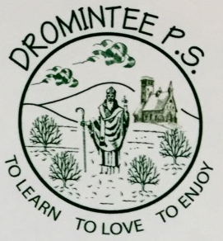 | Dromintee Primary School
 | 8 Ballynamadda Road,  Killeavy,  Newry, Co Down,  BT35 8TD | Telephone: (028) 3088 8383  Fax: (028) 3088 8470  www.drominteeps.com  Email: info@dromintee.killeavy.ni.sch.uk

Friday 20th March

Dear parent/carer,

All schools are now closed for the foreseeable future.

Further to the announcement regarding key workers, we would like to offer the following statement.

The Newry/South Down/South Armagh Primary Principals Group are keen to show our unreserved support for the ongoing challenge our healthcare services are currently facing. We realise we have a role to play in providing support for our communities.

However, with the lack of clarity, without a detailed operational plan from DE (by close of business today) and without appropriate protective measures in place we feel we cannot safely provide childcare for the children of key workers on Monday. We need adequate time to risk assess in our schools to ensure we can comply with Public Health Authority guidance relating to Personal Protective Equipment and social distancing.
We will use this time to work with our colleagues in DE/EA/CCMS/NICIE/CnaG to meet the challenges being faced.
At present medical professionals advise that the safest place for your children is at home.

We will keep you fully informed of further developments on Monday.

Yours sincerely

Wendy McKeown
Principal

