Refresher information on Mathletics
A Parent’s Guide
Mathletics is a relatively new ICT programme helping children at Dromintee Primary to enjoy maths and increase their breadth and depth of mathematical understanding. For children who do not have access to their log in details please email me: nmcardle278@c2kni.net in order to avail of this resource to support home-learning.

Mathletics has many aspects from quick fire calculations, times table music videos and interactive tutorials in line with the maths topics covered in the primary curriculum.

- Information on the free Mathletics Parental Console
We recommend that you spend time looking at the program with your child so that you can see how Mathletics will benefit his or her learning. Parents have access to a free Mathletics Parental portal which provides Report summaries of progress and lots more features. As a parent or guardian, you can sign up to receive weekly reports. These will provide you with details on your child’s progress and achievement.
To register for this service, you will need your child’s username and Password. Visit www.mathletics.co.uk/parents, complete the fields and click submit. Record your new username and password. I have also attached further information and guides on how to avail of this.

- Completion of set tasks by pupils
Each class teacher continues to set Mathletics activities as part of their home-learning support. However your child can access the additional apps in multi-verse and Live Maths to polish up on some of their recall skills. Levels for Live Maths can be set to suit the ability needs of your child.
We have been advised by Mathletics that if children receive too much help at home to complete the tasks, then the Mathletics assessment tool will record an overinflated score and the teacher will have an inaccurate understanding of the child’s progress. This may affect the difficulty of the next task set and may then demoralise or demotivate the child. Please keep your help with the actual answers to a minimum. All questions have a sound activation button if your child is struggling to read the actual question, thus encouraging them to use Mathletics more independently.

Mathletics knows which year group your child is in and will provide core exercises on all topics pitched at that age group. Your child is free to choose from these exercises. The level of challenge for the year group is said to be ‘core’ and it is possible, for most topics, to select ‘something easier’ or ‘something harder’ which would be the level of the year below and above respectively.
As your child completes these exercises the marks are recorded. The aim for each is to get a score above 80%. If a child receives a red, they will probably need additional practice at this concept.

- Celebrating pupil achievements
From 19th April we have started to tally the overall number of pupils accessing Mathletics on a weekly basis and celebrate pupils who have been awarded a Gold certificate each week and have compiled our own Top Ten Mathletics Hall of Fame. This list is generated by the Mathletics team and is based on overall usage and competence at completing activities.
Eg. Last week’s data table was presented in great detail:

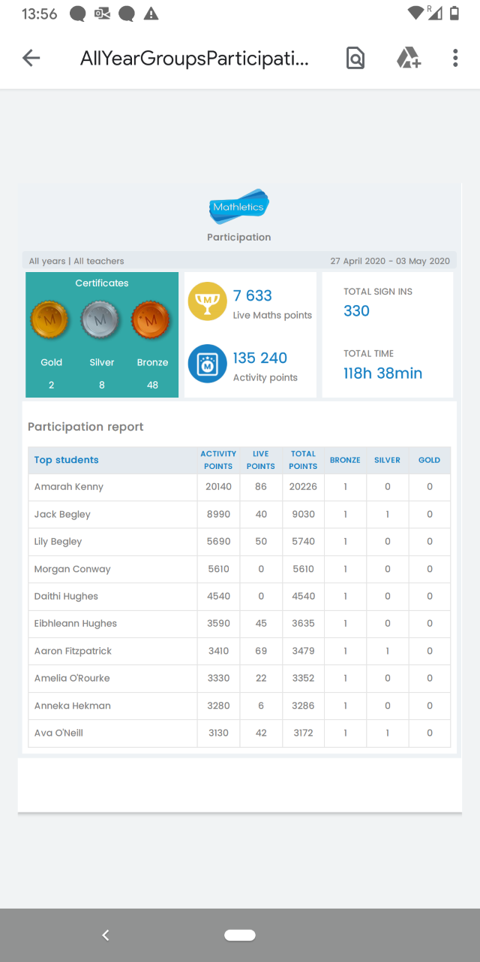

- How to gain Mathletics points
Earning points determines the type of certificate you achieve for the week. Points are reset every Sunday.
1000 points earned in a week = bronze certificate

5 bronze certificates = 1 silver certificate

4 silver certificates = 1 gold certificate

20 weeks of consistent weeks of work = 1 gold certificate

Finally please remember that achieving Gold Bars in activities and eventually Gold certificates is an indication that your child has understood all topics and tasks set, rather than accessing each activity just once or twice. The content and questions vary each time you play an activity.

When all set tasks have been completed your child will have access to the Problem Solving tasks pertaining to their class level found in the Explore tab on the toolbar.

I hope this is some assistance to guide you on how to make the best use out of Mathletics at home.

Take care,
Mrs Mc Ardle

Further information
Mathletics for Parents A guide for Parental Area.

I have also attached a guide on how to use the Parent portal and a poster displaying the Mathletics points.

