My townland Tievecrom
I live in the townland Tievecrom, just as some of my ancestors before me; any ancestors that lived on the Tievecrom rd lived in the same 3 roomed house.
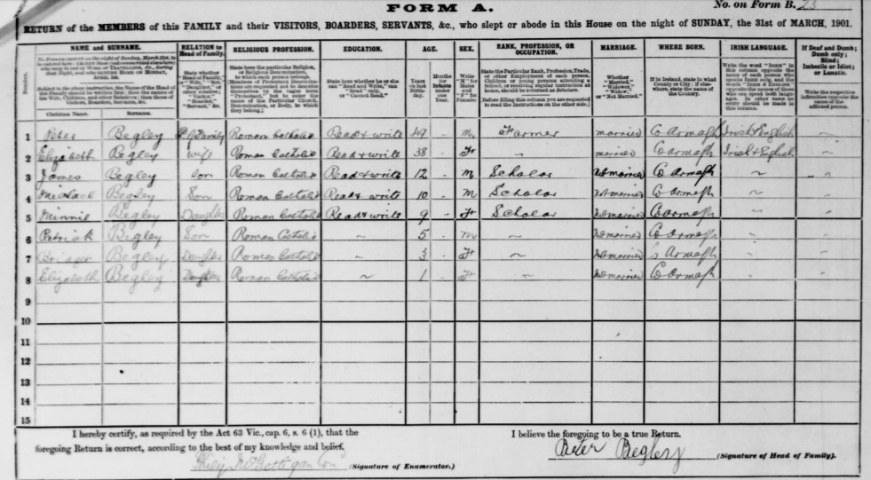
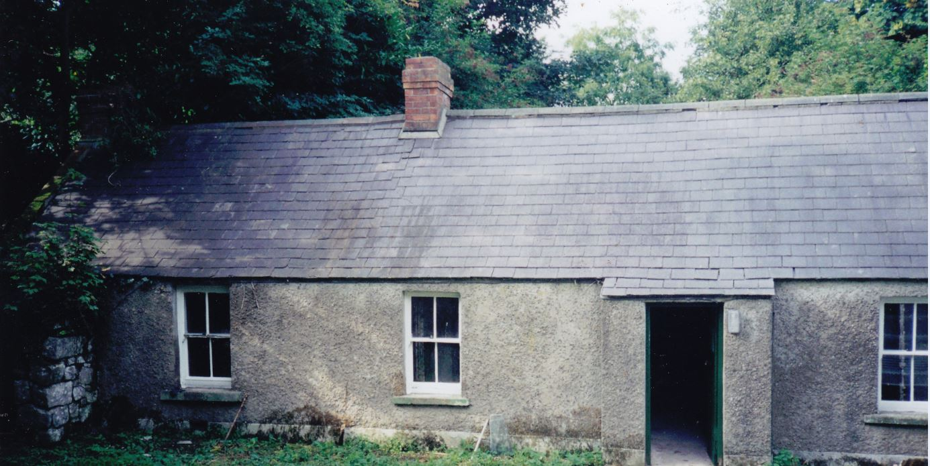
As the census shows in 1901 there were 6 children and 2 adults all living in that small house and in this census there is a girl called Minnie,
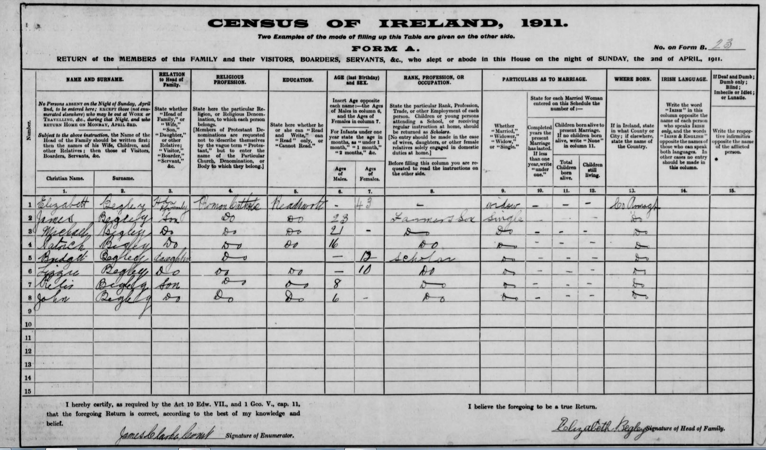
But then in the 1911 census you can see that Minnie is not in it so that means that Minnie died between the year 1901 and 1911, so you can really see a lot from the census.
Also in these censuses you can see that in 1901 there was a husband and wife but in 1911 there is only the wife left so the husband died as well so the mother had to raise 7 kids all by herself.
This small house has been passed through my family for generations my granda lived in that house when he was growing up, even my parents lived in that house when they got married. So the Begley family have owned this house for about 119 years at least! Now my uncle lives in the same spot just in a different house.

