My Townland
Dernaroy
I live in Dernaroy in the land of Dromintee under the shadow of Slieve Gullion. I moved up here when I was 6 years old and I have been living in my house for 4 years now. I love where I live and all the people in the community are so nice and very welcoming. When I moved up here we had no cousins or relatives in the locality so we knew nobody. Thankfully we had a warm welcome and now we are all friends.
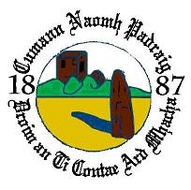
This is a picture of the Dromintee logo based on history.

Dernaroy is located between my school, Dromintee P.S and Jonesbrough village . If you were coming from Meigh it is the 2nd road on your left and you will see Dernaroy Road on the sign. If your coming from the Three Steps it is the 3rd road on your left with a Dernaroy sign.

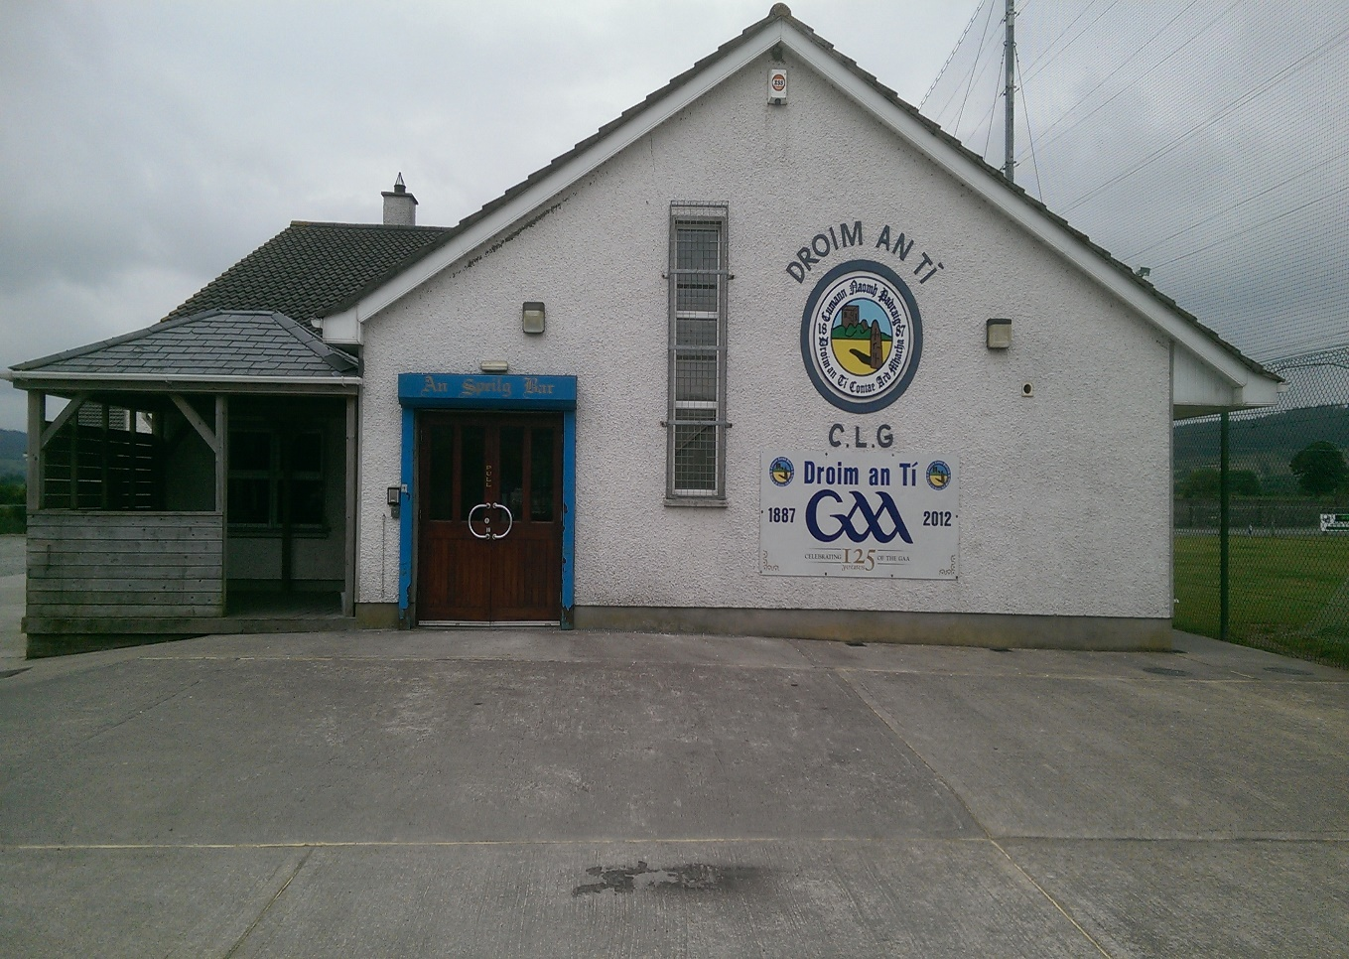
This is Dromintee GAC where my family and I go to play our favourite sport, Gaelic Football. I joined the club when I was 6 years old and from there we have grown so much as a team. I absolutely love to play the sport and get involved in the club , my Dad [Declan McBennett] is currently the Juvenile Secretary of the club and he loves to take part in the club also .

We usually have 3 blitzes a year for Under 8 , 10 and 12. Since 2018 we have grown to Under 8 , 10 and 12 for boys and Under 8 girls and 10 girls which is brilliant for me as a girl and all other female footballers because I think women are just as men in every aspect .
I have no relations round Dromintee , but my Grandad is originally from Silverbridge and that’s just over the road so I have a lot of relations there which is great. My family and I used to live in Lisburn in County Antrim. My 3 brothers and I were all born in The Royal in Belfast and I am the 2nd oldest in my family. My Dad is from Castleblayney in Monaghan, and my mum is from Carryduff in County Down so we are really blow in’s around here.

