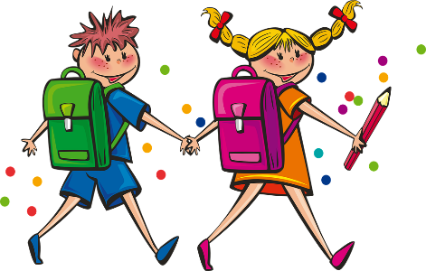P3 boys and girls,

It is so hard to believe that the end of June has arrived and with it the end of our year together in P3. I am so proud of how hard you have worked both in school and at home with your parents. You have been a fantastic group of children and I have wonderful memories of our time together. I have really enjoyed being your teacher and I will miss you all next year. I hope you have a summer filled with fun and laughter. You deserve it!

Stay safe and enjoy the break,

Miss McCann

