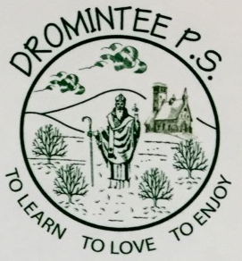 | Dromintee Primary School
 | 8 Ballynamadda Road,  Killeavy,  Newry, Co Down,  BT35 8TD | Telephone: (028) 3088 8383  Fax: (028) 3088 8470  www.drominteeps.com  Email: info@dromintee.killeavy.ni.sch.uk
3rd August 2020
A theaghlaigh scoile, a chairde,
I hope you are all well.
The changes in our lives due to the COVID-19 have been many. Unfortunately, the impact of the virus continues to change the most fundamental aspects of how we live, including how we engage with school. While we cannot predict what the COVID-19 pandemic will look like this Autumn, we plan to implement a number of enhanced health and safety measures, based on guidance from local health and government authorities – EA and CCMS. The Minister for Education stated, ‘the ongoing management response to COVID-19 is taking place in a fluid and changing environment, with guidance to society evolving on an almost daily basis’.

Aside from a child’s home, there is no other setting which has more of an influence on a child’s health and well-being than their school. The in-person school environment provides academic instruction, supports the development of social and emotional skills, creates a safe environment for learning, addresses nutritional needs and facilitates physical activity.

School leaders have been working tirelessly to develop plans for the safe return of as many pupils as possible in order to best meet our pupils’ academic, social-emotional and faith-based needs. Over the coming weeks, we will be meeting to discuss site-specific plans. Based upon the current medical status, the hope today is for pupils to return to full in-person instruction in September; however, this is merely a tentative plan and schedules may vary, and the re-entry plans are subject to change, based upon the final determination, to be made by the Department of Education and CCMS.

The health and safety of the children and adults in our schools is paramount. Health and safety considerations must always come first in every decision made and every action taken by our school leadership. In planning for school opening, our goal is to establish best practices for ensuring a healthy and safe return to school. This will include but not limited to: health checks; healthy hygiene practices; social distancing; and cleaning and disinfection.

Thank you for your patience as we continue to navigate these extraordinary times. We acknowledge that there are likely to be more questions than answers at this time, and we will share our plans with you on Tuesday 18th August.

I hope you get to enjoy some family time during what’s left of the summer.
Le dea-ghuí,
Bean Mhic Eoin

