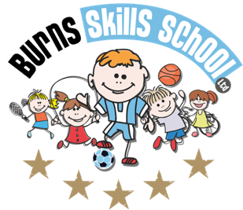
Basketball

Dear Parent/Guardian
We are delighted to announce that Burns Skills School are running one of their fantastic afterschool programmes within the school grounds this year. The programme will consist of 9 weeks which will entail age appropriate educational sessions that will have a main focus of fun whilst improving each child’s technical ability.
Dates of programme:
Monday 12th Oct
Monday 19th Oct
Monday 2nd Nov
Monday 9th Nov
Monday 16th Nov
Monday 23rd Nov
Monday 30th Nov
Monday 7th Nov
Monday 14th Nov

Primary 1, 2, & 3 (2.00pm-3.00pm each week) Primary 4, 5, 6 & 7 (3.00pm-4.00pm each week) To secure a place for your child you must attend our new registration morning with payment of £36.00.

Registration date & time: Tuesday 6th October 8.30am-9.00am (School grounds)

NOTE: IF YOU HAVE ANY OUTSTANDING SESSIONS FROM TERM 2 LAST YEAR PLEASE GET IN CONTACT BEFORE NEXT TUESDAY SO WE CAN ORAGNISE YOUR DISOCUNT.

Only 16 places MAXIMUM available for each session.

Benefits of programme:

- Improves technical ability
- Enhances physical, mental and social attributes (confidence building)
- Professional coaching
- Controlled and structured physical activity
- Teaches respect for one and all
- Make new friends

Deadline for forms & payment is _____________________________________. This is a great opportunity for your child and certainly one not to be missed. When in attendance we would advise that all children wear appropriate clothing with a pair of trainers suitable for indoor and outdoor.

Payment options: Cash

Thanks
Aaron & Andrew
Burns Skills School

