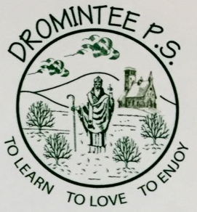 | Dromintee Primary School
 | 8 Ballynamadda Road,  Killeavy,  Newry, Co Down,  BT35 8TD | Telephone: (028) 3088 8383  Fax: (028) 3088 8470  www.drominteeps.com  Email: info@dromintee.killeavy.ni.sch.uk

4th January 2021

Dear parents and school families,
At Dromintee Primary School, we are committed to the best for each and every child. We follow the guidelines issued by the Departments of Health and Education. DE has been issuing a series of directives over the holidays, sometimes within hours it is amended.

Locally, there is a significant amount of concern in light of the trajectory of the C-19 virus and its increased transmissibility. Parish Masses have been suspended. We have a duty of care to all pupils and staff and will follow Public Health guidance to reduce transmission.

Be assured that positive, proactive contingency planning was undertaken before the Christmas break by myself and the vice-principal and shared with the Chair of Governors. The pandemic situation (and with it PHA advice) is fluid and evolving. We move to on-line learning on Thursday 7th January and Friday 8th January 2021. Before the end of the school day on Friday 8th we will issue clear, unambiguous communication to allow our families to plan for the following week.
Wishing you and your families every blessing for 2021.
Mrs W McKeown

