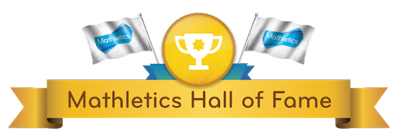

January Gold Certificates

Ferghal Mc Coy P3
Feidhlim Hughes P4
Matthew Geoghegan P7

Congratulations boys for all your hard work achieving a Gold Certificate in the Month of January. We will celebrate this achievement when we return to school soon.
Well done!

