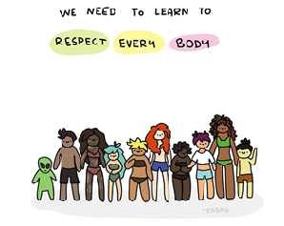
Dealing with Bad Body Image Days
Breathe. Mindfulness is a great way to connect with your body and develop a greater appreciation of it. There are lots of free apps such as Headspace and Oak that can help with this.
Practice body gratitude. What are you grateful for your body for? Think of all the things it does for you.
Write it down. Journaling can be a really healthy outlet for your emotions.
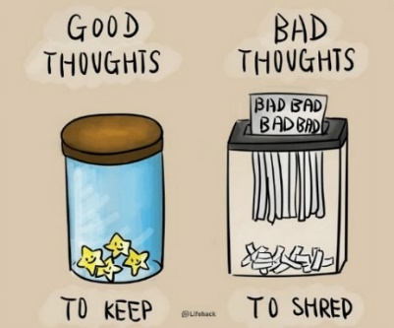
Challenge your inner critic. Practice reframing those negative thoughts. For example, if you think ‘my tummy is too big’, try coming up with a positive thought replacement such as, ‘my tummy contains life sustaining organs that need space to function’
Dress comfortably. If you are conscious about a particular aspect of your body, wear clothes that don’t emphasise your insecurities.
Talk to yourself like you would a friend. What advice would you give them if they told you they were struggling with the way they look?
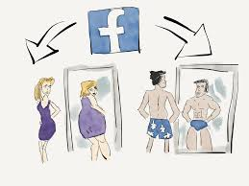
Be kind to yourself. Create a comfort list of simple things you can do to offer yourself a moment of kindness (music/affirmations/activities). If you find kindness too difficult using neutral comments can also be helpful. “I have a body but it does not define my worth.” “I am more than my appearance.”
Be mindful of social media. Social media can encourage unhealthy comparison between ourselves and seeming ‘perfect’ others. Be aware that not everything we see online reflects reality. Maybe you need some time to disconnect?
Body image fluctuates. Remember, how you feel is not permanent.

