What will I be learning in P4?

Literacy:
- Reading exciting texts, plays, poetry and non- fiction.
- You will be taking part in group discussions and using audio equipment to practise your public speaking.
- You will be writing for various different audiences and learning how to spell and write many new words.

Numeracy:
- You will be learning your times tables, division facts and number bonds.
- You will know lots of new mathematical words.
- You will learn lots of new skills and become much quicker with your mental maths recall facts.

Religion:
- You will be preparing for your Enrolment, First Confession and First Holy Communion.
- You will be learning lots of Bible stories.
- You will practise your prayers every day and learn how to sing many new songs.

and…

World Around Us
ICT
Art
Music
PE
And much much more………………………

Help at Home
Dear Parent(s),

I want to make the change of class as easy as possible for your child. You can help them by:

- Ensuring ALL their possessions, especially jumpers and coats are labelled clearly with their name.
- Encouraging your child’s growing independence- letting them sort out their own lunchbox, break, coat, shoes etc. I understand that this takes time at first, but it is great for developing independence as a learner.
- Listen to them read or ask them about their books and encourage them to read every day.
- Practising numeracy skills in an informal way- number games, mental maths and table facts.
- Encouraging and supporting them to do their homework by themselves.
- Let me know if you or your child have any worries-no matter how small.


Welcome to Primary Four
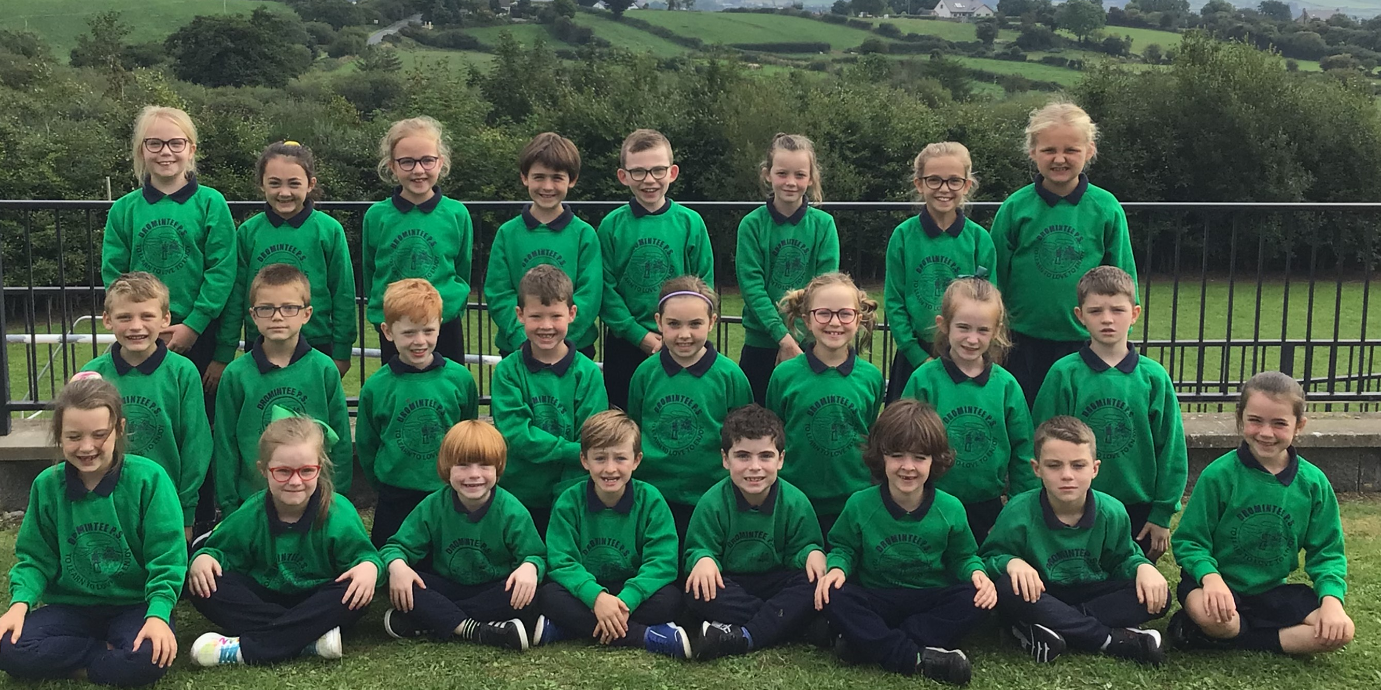

2021-2022

Mrs English

I am delighted to see all the happy new P4 faces and I look forward in getting to know you. I know you will all work very hard in Primary Four.

Remember to talk to me if you have any questions or worries this year.

Mrs English

In Primary 4 you will be expected to:
- Always try your best.
- Be kind and considerate to everyone.
- Do your homework.
- Read regularly to an adult at home.
- Look after your own things.
- Remember to take a healthy break everyday.

Enjoy school and be happy!


Basic things you must know by the end of P4How to spell:
- Your name and surname
- Days of the week
- Months of the year
- Numbers 1-20
- Numbers 10,20,30,40,50,60,70,80,90,100

Commonly misspelt words:

said does could laugh friend because with why were made people many half who they

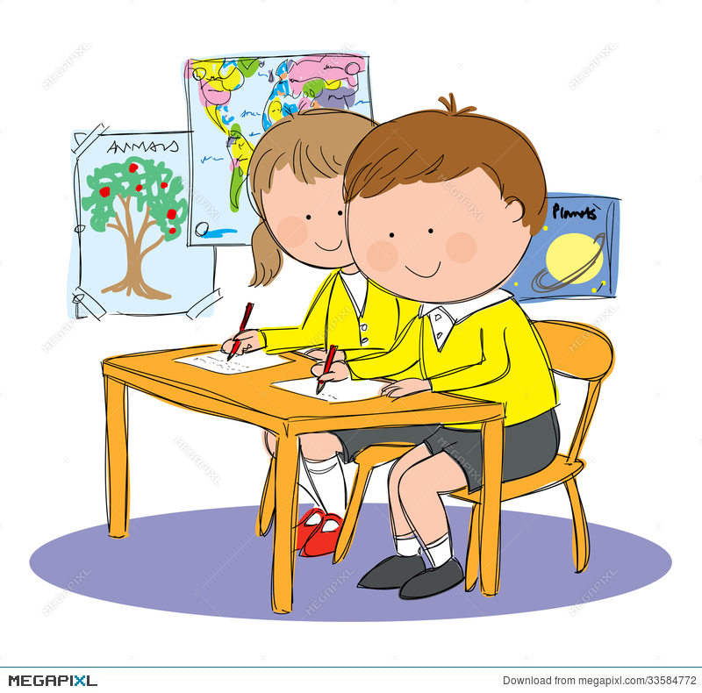
- You must be able to form your letters properly especially b, p and d.
- g,j,p,q,y hang on the line.
- b,d,f,h,k,l,t stand tall on the line.
- You must be able to write all letters in lower and upper case as we will be starting to practice joined up writing after Christmas.

Number:
- Table facts x2, x3, x4, x5, x10
- Number facts to 100.
- Count to 1000.

Things to remember:

PE
Greg will be in school every Tuesday, please bring in the correct gear you need to play Gaelic. PE is every Thursday, please wear tracksuit bottoms and trainers. It is also important not to wear any jewellery for safety reasons.

Homework
- Homework will be distributed every Monday for the coming week.

- Spelling homework will be given each night.

- Reading must be done every night, either guided reading or AR reading. An adult must sign your reading record book.

- Homework books will be collected every Thursday morning.

- Grow in Love homework will be given on Thursday night. It is important that the homework is completed and signed and returned to school on Friday morning.

- We are continuing to use Seesaw as a learning resource, an activity will be set every Thursday night for homework.

- Mathletics tasks will be set each week.

- Your homework diary or homework book must be signed by a parent every night.

