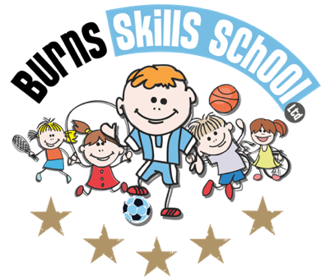
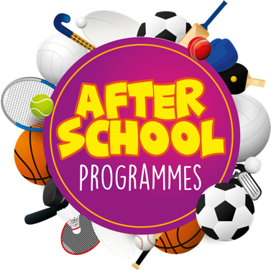
Soccer

Dear Parent/Guardian
We are delighted to announce that Burns Skills School are running one of their fantastic afterschool programmes within the school grounds this year. The programme will consist of 10 weeks which will entail age appropriate educational sessions that will have a main focus of fun whilst improving each child’s technical ability.
Dates of programme:
Friday 14th Jan
Friday 21st Jan
Friday 28th Jan
Friday 4th Feb
Friday 25th Feb
Friday 4th Mar
Friday 11th Mar
Friday 25th Mar
Friday 1st Apr
Friday 8th April

Primary 1, 2, & 3 (2.00pm-3.00pm each week) Primary 4, 5, 6 & 7 (3.00pm-4.00pm each week). To secure a place for your child you must make payment of £40.00 at our registration morning.

Registration date & time: Tuesday 11th of January at 8.15am

Benefits of programme:

- Improves technical ability
- Enhances physical, mental and social attributes (confidence building)
- Professional coaching
- Controlled and structured physical activity
- Teaches respect for one and all
- Make new friends

Deadline for forms & payment is Tuesday 11th of January. This is a great opportunity for your child and certainly one not to be missed. When in attendance we would advise that all children wear appropriate clothing with a pair of trainers suitable for indoor and outdoor.

Payment options: Cash

Thanks
Aaron & Andrew
Burns Skills School

