March is Mental Maths Mathletics Month
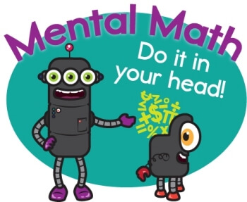
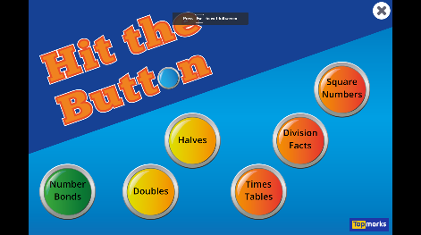
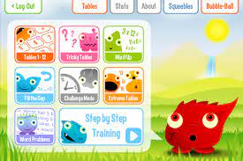

This month we are encouraging everyone to
improve their mental maths skills.

There are lots of different ways you can do this:
- Practice your counting on/ back number sequences
- Recall number bonds
- Recite your times tables (pick a different one every day)
- Complete your Mental Maths class activities
- Play Hit the Button - Quick fire maths practise for 6-11 year olds (topmarks.co.uk)
- Play the Squeebles app on your iPad
- Play Mathletics Live games
- Play Mathletics Multiverse games
- Participate in Mathletics World Maths Day

On Wednesday 23rd March we will participate in Mathletics World Maths Day.

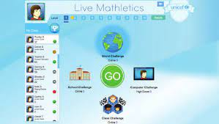
March Maths awards include: Gold certificate recipients
Top two pupils with the most Mathletics Live points in the month of March in P3-P7
Top Ten Leaderboard on Mathletics World Maths day will also receive a small prize for their great efforts

