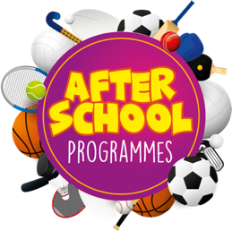
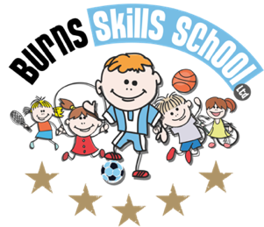
Multisport

Dear Parent/Guardian
We are delighted to announce that Burns Skills School are running one of their fantastic afterschool programmes within the school grounds this year. The programme will consist of 10 weeks which will entail age appropriate educational sessions that will have a main focus of fun whilst improving each child’s technical ability.
Dates of programme:
Thursday 15th Sept
Thursday 22nd Sept
Thursday 29th Sept
Thursday 6th Oct
Thursday 13th Oct
Thursday 20th Oct
Thursday 27th Oct
Thursday 10th Nov
Thursday 17th Nov
Thursday 24th Nov

Primary 1 – Primary 3 (2.00pm-3.00pm each week) Primary 4 – Primary 7 (3.00pm-4.00pm)

To secure a place for your child you must enrol online via www.burnsskillsschool.co.uk This is very easy and straightforward. Click ‘secure your place’ at the top of the website. Then scroll down to find your child’s school and the correct activity to enrol. Cost: £40.00.

Benefits of programme:

- Improves technical ability
- Enhances physical, mental and social attributes (confidence building)
- Professional coaching
- Controlled and structured physical activity
- Teaches respect for one and all
- Make new friends

Deadline for payment is Tuesday 13th September. This is a great opportunity for your child and certainly one not to be missed. When in attendance we would advise that all children wear appropriate clothing with a pair of trainers suitable for indoor and outdoor.

Payment options: PayPal

Thanks
Aaron & Andrew
Burns Skills School

